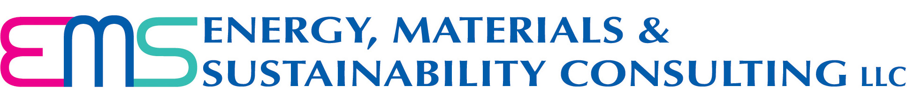

Mission Statement

To foster growth in the business community by driving sustainable business practices.

Vision Statement

EMS Consulting, a knowledge repository for sustainability, will continue to grow its knowledge, skill, capability, expertise and reputation to become a valued, innovative provider of services in each of its 5 core competencies, including,

a) Regulatory Compliance to meet both environmental and OSHA requirements,
b) Management Systems – ISO 50001 for energy, ISO 4500 and OHSAS 18001 for workplace safety and health, ISO 14001 for environmental, ISO 22000 for food safety & ISO 9001 for quality management systems,
c) Energy Efficiency and Energy Conservation,
d) Materials Management, Clean Manufacturing and Lean Manufacturing, and
e) Sustainability services for organizations, buildings and energy-consuming equipment and systems.

We will deliver consulting services and sell related equipment and systems within each of these technology focus areas. We will go where the work is, but concentrate on the eastern 2/3 of Pennsylvania, and all of Delaware, Maryland and New Jersey.

EMS Consulting will expand via trusted network partners within its area of core competencies and geography as identified herein.

Within 3 years, EMS Consulting will be a mature consulting and manufacturer’s rep firm with dozens of completed projects and satisfied customers.

Core Competencies

EMS Consulting’s core competencies shall be confined to the 5 technology areas identified in its Vision Statement.

Service Delivery Modes

In order to deliver world-class services in each of these technology areas, EMS Consulting uses the following service delivery modes and maintains expertise in each:

- Analyses, Assessments and Audits
- Specialized and Customized Training
- Plan Development
- Certifications / Implementation Assistance
- Consultation / Facilitation
- Specialty Tools
- Reporting
- Permitting

